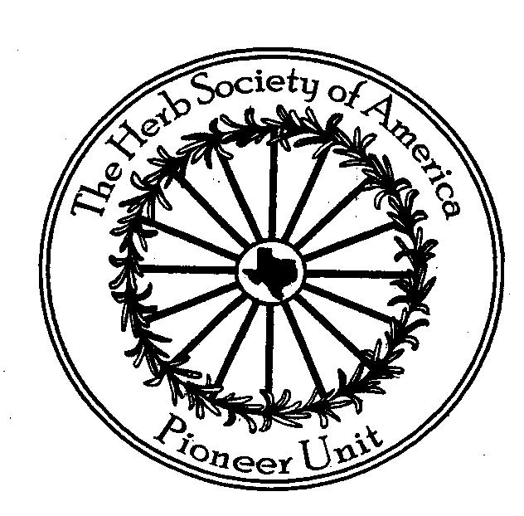
Herb Society of America, Pioneer Unit
Madalene Hill Scholarship

Academic Scholarship Award
$1000 - $4000

For High School Seniors or College Students studying Plant Sciences or Horticulture or Environmental Sciences with a focus on Botany or Food Sciences or a closely related discipline.

APPLICATION FORM
Please note that ALL sections must be completed and supporting materials enclosed for your application to be considered.
- Personal Information
Your name: (last)______________________(first)___________________(middle)__________________
School______________________________________________________________________________
Address_____________________________________________________________________________
City____________________________________State______________Zip Code___________________
Phone Number___________________________________
- Academic Information: list school or university now attending and any previous attended
Name of High School or University Location Dates Attended
____________________________ ___________________ _______________________________
___________________________ ___________________ _______________________________
If attending university, what is your major:_____________________________________________
- Academic Performance:
Grade Point Average___________________ (Enclose an official transcript from school)
- Recommendations:
Have one of your professors or guidance counselors write a letter of recommendation
supporting your application and enclose with the application (must be on school stationary in a sealed envelope for confidentiality to be valid).
- Careers and Interest Summary from Applicant:
Write two or three paragraphs summarizing your short-term and long-term career goals.
Include any examples of special interests or projects in plants, herbs, gardening,

Deadline for Submission: May 1, 2026
Mail to: Pioneer Unit of the Herb Society of America
P.O. Box 23 Round Top, TX 78954
Attn: Phoebe Lake

